**UCS 2312 Data Structures Lab**

**Assignment 3: Doubly Linked List and its applications**

**Date of Assignment: 19.09.2023**

Create an ADT for the doubly linked list data structure with the following functions. Each node which consists of integer data, address of left and right nodes [CO1, K3]

Create a ListADT which has implementations for the following operations

1. Insert an item in the front of the list

void insertFront(listADT L, int c)

1. Insert an item at the end of the list

void insertEnd(listADT L, int c)

1. Insert an item ‘d’ after the first occurrence ‘c’ of the list

void insertMiddle(listADT L, int c, int d)

1. Display the items from the list

void displayItems(listADT L)

1. Delete the item present in the list

void deleteItem(listADT L, int c)

1. Search an element in the list and return the number of occurrences

int searchItem(listADT L, int c)

Write a program in C to test the ListADT for its operations with the following test cases.

Testcase:

Initially L is Empty

insertFront(L,6) 🡪 header🡨🡪6

insertEnd(L,2) 🡪 header🡨🡪2🡨🡪6

insertMiddle(L,2,1) 🡪 header🡨🡪2🡨🡪1🡨🡪6

insertMiddle(L,2,1) 🡪 header🡨🡪2🡨🡪1🡨🡪1🡨🡪6

search(L,1) 🡪 2

In addition, do the following operations:

1. Check whether the list contains duplicates?
2. Create separate lists containing even and odd numbers from the list
3. Add two 10-digit numbers using the list

**Data Structure – Double Linked List:**

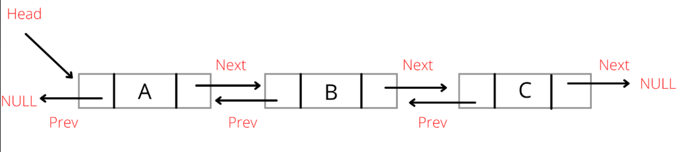

**Algorithm –**

**Algorithm: Checks whether the list contains duplicates**

Input – Pointer to header node

Output – int

1. ptr1= header->right
2. while (ptr1 != NULL)

ptr2 = ptr1->right

while (ptr2 != NULL)

if (ptr1->data == ptr2->data)

return 1

ptr2 = ptr2->right

ptr1 = ptr1->right

1. return 0

**Algorithm: Create separate lists containing even and odd numbers from the list**

Input – Pointer to header, pointer to odd header, pointer to even header

Output – void

1. ptr = header->right
2. while (ptr != NULL)

if (ptr->data % 2 == 0)

insertEnd(even_head, ptr->data)

else

insertEnd(odd_head, ptr->data)

ptr = ptr->right

**Algorithm: Add two 10-digit numbers using the list**

Input – Pointer to number1 header, pointer to number2 header

Output – struct node *

1. p1 = n1->right
2. p2 = n2->right
3. res->left = NULL
4. res->right = NULL
5. carry = 0
6. while (p1 != NULL)

end1 = p1

end2 = p2

p1 = p1->right

p2 = p2->right

1. p1 = end1
2. p2 = end2
3. while (p1 != n1)

sum = p1->data + p2->data + carry

if sum > 9

carry = 1

insertFront(res, sum%10)

else

carry = 0

insertFront(res, sum)

p1= p1->left

p2 = p2->left

1. if carry==1

insertFront(res, 1)

1. return res

**DLinkedListADT.h code:**

struct node

{

int data;

struct node* left;

struct node* right;

};

void insertFront(struct node* header, int c)

{

struct node* temp;

temp=(struct node*)malloc(sizeof(struct node));

temp->data=c;

if(header->right==NULL)

{

temp->right=header->right;

temp->left=header;

header->right=temp;

}

else

{

struct node* ptr;

ptr=header->right;

temp->right=ptr;

ptr->left=temp;

header->right=temp;

temp->left=header;

}

}

void displayItems(struct node* header)

{

struct node* ptr, *end;

ptr=header->right;

printf("\nForward: ");

while(ptr!=NULL)

{

printf("%d ", ptr->data);

end=ptr;

ptr=ptr->right;

}

printf("Backward: ");

while(end!=header)

{

printf("%d ", end->data);

end=end->left;

}

}

struct node* search(struct node* header, int key)

{

struct node* ptr;

ptr=header->right;

while(ptr!=NULL)

{

if(ptr->data==key)

return ptr;

ptr=ptr->right;

}

return NULL;

}

void insertMiddle(struct node* header, int key, int data)

{

struct node* temp;

temp=(struct node*)malloc(sizeof(struct node));

struct node *ptr, *next;

ptr=search(header,key);

if(ptr==NULL)

printf("\nNot found.");

else

{

temp->data=data;

next=ptr->right;

ptr->right=temp;

temp->left=ptr;

temp->right=next;

next->left=temp;

}

}

void insertEnd(struct node* header, int data)

{

struct node* temp;

temp=(struct node*)malloc(sizeof(struct node));

struct node *ptr;

ptr=header;

while(ptr->right!=NULL)

ptr=ptr->right;

temp->data=data;

ptr->right=temp;

temp->left=ptr;

temp->right=NULL;

}

void deleteItem(struct node* header, int data)

{

struct node *prev, *next, *ptr;

ptr=search(header,data);

prev=ptr->left;

next=ptr->right;

prev->right=next;

next->left=prev;

free(ptr);

}

int searchItem(struct node* header, int c)

{

int count=0;

struct node* ptr=header->right;

while(ptr!=NULL)

{

if(ptr->data==c)

++count;

ptr=ptr->right;

}

return count;

}

int duplicates(struct node* header)

{

int flag;

struct node* ptr1=header->right, *ptr2;

while(ptr1!=NULL)

{

ptr2=ptr1->right;

while(ptr2!=NULL)

{

if(ptr1->data==ptr2->data)

return 1;

ptr2=ptr2->right;

}

ptr1=ptr1->right;

}

return 0;

}

void evenOdd(struct node* header,struct node* even_head,struct node* odd_head)

{

struct node *ptr = header->right;

while (ptr != NULL)

{

if ((ptr->data) % 2 == 0)

insertEnd(even_head, ptr->data);

else

insertEnd(odd_head, ptr->data);

ptr = ptr->right;

}

}

int palindrome(struct node* header)

{

struct node* ptr=header->right;

struct node* end;

while(ptr!=NULL)

{

end=ptr;

ptr=ptr->right;

}

if(header->right!=NULL)

{

ptr=header->right;

while(ptr!=NULL && end!=header)

{

if(ptr->data!=end->data)

return 0;

ptr=ptr->right;

end=end->left;

if(ptr==end)

break;

}

}

return 1;

}

struct node* add10Digit(struct node* n1,struct node* n2)

{

struct node* res=(struct node*)malloc(sizeof(struct node));

struct node *p1,*p2,*end1,*end2;

p1=n1->right;

p2=n2->right;

res->left=NULL;

res->right=NULL;

int sum,carry=0;

while(p1!=NULL)

{

end1=p1;

end2=p2;

p1=p1->right;

p2=p2->right;

}

p1=end1;

p2=end2;

while(p1!=n1)

{

sum=p1->data+p2->data+carry;

if(sum>9)

{

carry=1;

insertFront(res,sum%10);

}

else

{

carry=0;

insertFront(res,sum);

}

p1=p1->left;

p2=p2->left;

}

if(carry==1)

{

insertFront(res,1);

}

return res;

}

**Main.c code:**

#include <stdio.h>

#include <stdlib.h>

#include <string.h>

#include "DLinkedListADT.h"

void main ()

{

struct node* header;

header = (struct node*)malloc(sizeof(struct node));

header->left = NULL;

header->right = NULL;

int choice;

while(choice + 1)

{

printf("\n-1: EXIT\n 0: DISPLAY ITEMS\n 1: INSERT AT FRONT\n 2: INSERT AT END\n 3: INSERT AT MIDDLE\n 4: DELETE ITEM");

printf("\n 5: SEARCH ITEM\n 6: CHECK DUPLICATES\n 7: SEPARATE EVEN AND ODD\n 8: ADD 10 DIGIT NO.\n 9: CHECK PALINDROME\nChoice : ");

scanf("%d", &choice);

switch (choice)

{

case -1: break;

case 0:

{

displayItems(header);

printf("\n");

break;

}

case 1:

{

printf("\nENTER NEW ELEMENT: ");

int data;

scanf("%d", &data);

insertFront(header,data);

displayItems(header);

printf("\n");

break;

}

case 2:

{

printf("\nENTER NEW ELEMENT: ");

int data;

scanf("%d", &data);

insertEnd(header,data);

displayItems(header);

printf("\n");

break;

}

case 3:

{

printf("\nENTER NEW ELEMENT AND TO INSERT AFTER: ");

int data,key;

scanf("%d", &data);

scanf("%d", &key);

insertMiddle(header,key,data);

displayItems(header);

printf("\n");

break;

}

case 4:

{

printf("\nENTER ELEMENT: ");

int data;

scanf("%d", &data);

deleteItem(header,data);

printf("ELEMENT DELETED\n");

displayItems(header);

printf("\n");

break;

}

case 5:

{

int search,c;

printf("\nEnter element to search: ");

scanf("%d", &search);

c=searchItem(header,search);

printf("\nThe no. of occurences of %d in the list is %d.\n",search, c);

break;

}

case 6:

{

if(!duplicates(header))

printf("\nNo duplicates present.");

else

printf("\nDuplicates present.");

printf("\n");

break;

}

case 7:

{

struct node *even_head = (struct node *)malloc(sizeof(struct node));

even_head->left = NULL;

even_head->right = NULL;

struct node *odd_head = (struct node *)malloc(sizeof(struct node));

odd_head->left = NULL;

odd_head->right = NULL;

evenOdd(header,even_head,odd_head);

printf("\nEven List: ");

displayItems(even_head);

printf("\nOdd List: ");

displayItems(odd_head);

printf("\n");

break;

}

case 8:

{

struct node *n1=(struct node *)malloc(sizeof(struct node));

n1->left=NULL;

n1->right=NULL;

struct node *n2=(struct node *)malloc(sizeof(struct node));

n2->left=NULL;

n2->right=NULL;

struct node *sum=(struct node *)malloc(sizeof(struct node));

sum->left=NULL;

sum->right=NULL;

char num1[11],num2[11];

printf("Number 1 : ");

scanf("%10s", num1);

printf("Number 2 : ");

scanf("%10s", num2);

for(int i=0;i<10;i++)

{

insertEnd(n1,(num1[i]-'0'));

}

for(int i=0;i<10;i++)

{

insertEnd(n2,(num2[i]-'0'));

}

printf("Number 1 : ");

displayItems(n1);

printf("\n");

printf("Number 2 : ");

displayItems(n2);

printf("\n");

sum=add10Digit(n1,n2);

printf("Sum : ");

displayItems(sum);

printf("\n");

break;

}

case 9:

{

if(palindrome(header))

printf("\nPalindrome.");

else

printf("\nNot Palindrome.");

printf("\n");

break;

}

default:

{

printf("\nINVALID CHOICE");

}

}

}

}

**Output Screen:**

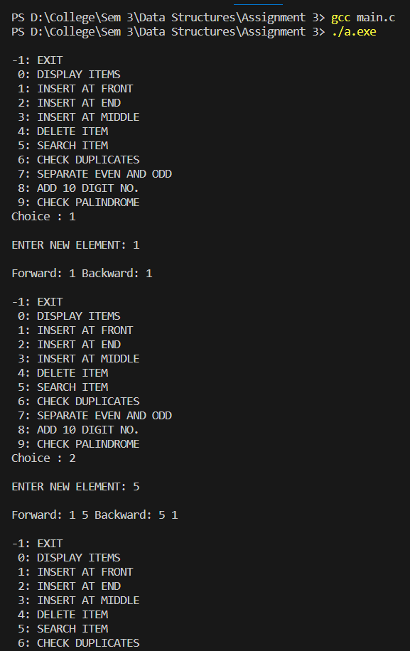

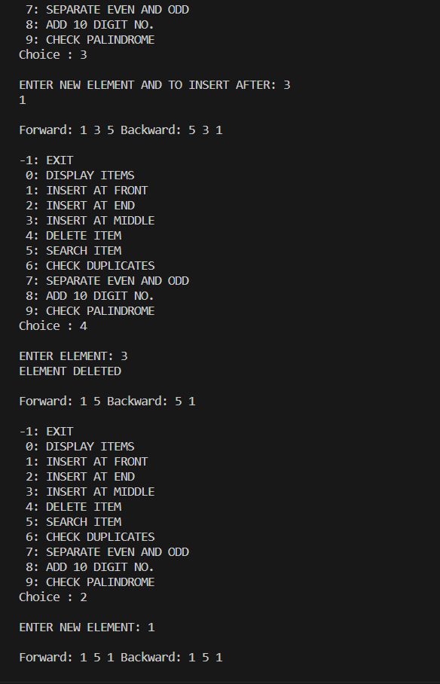

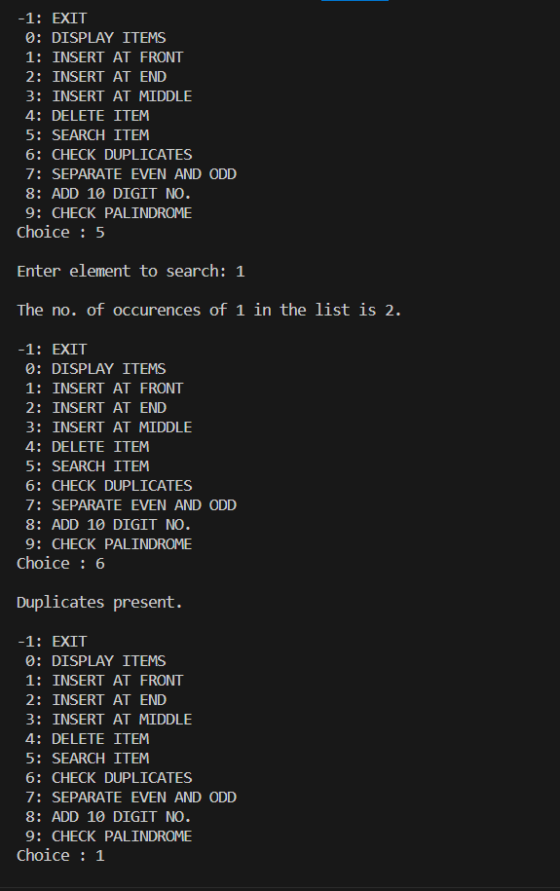

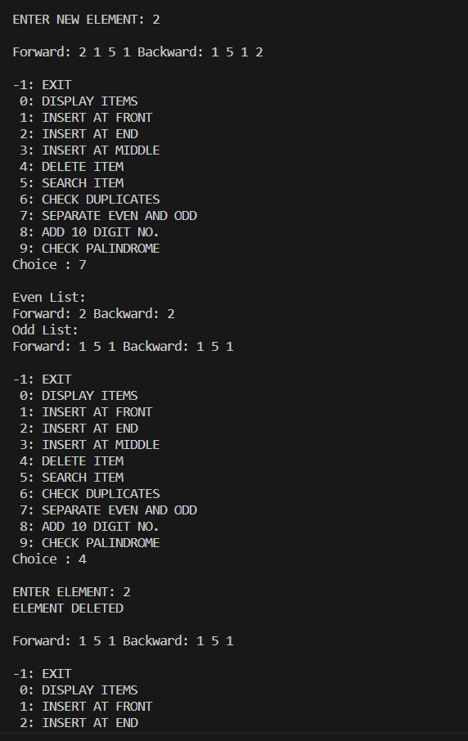

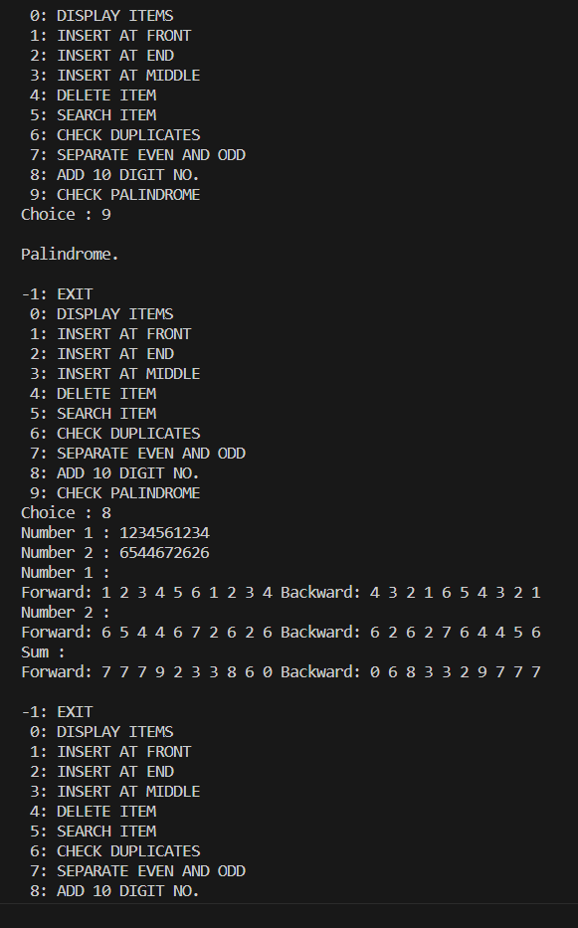

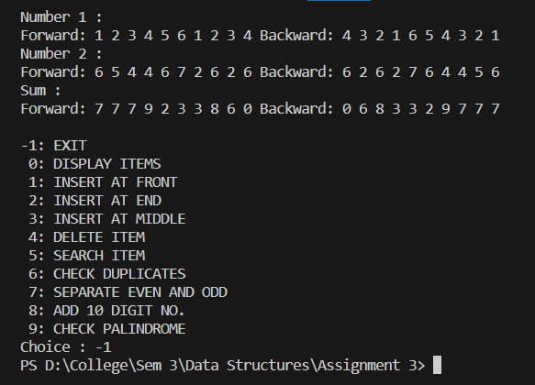

**Learning Outcome:**

